**RECYCLE … USE PUBLIC TRANSPORTATION … MAKE GOOD CHOICES AT THE DRIVE THRU ???**

Only recently did I become aware of the environmental impact of my food choices. On its website, the EPA (Environmental Protection Agency) defines GWP (Global Warming Potential) as a measure of gases other than CO2 and how they warm the Earth. The information below provides some facts about the GWP of methane (a gas generated by beef/pork production):

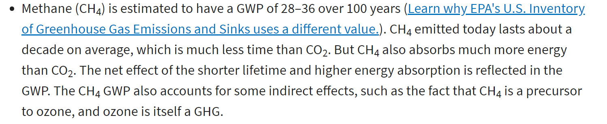

link: <https://www.epa.gov/ghgemissions/understanding-global-warming-potentials>

In addition to the impact on your waistline and your health, biting into that burger can cost you (and your planet) quite a few miles … 9.81 for every half pound (or 7.40 pounds of CO2-equivalent emissions from producing half a pound of beef – LINK: [How Meat Contributes to Global Warming - Scientific American](https://www.scientificamerican.com/slideshow/the-greenhouse-hamburger/)).

MEAT ON THE STREET

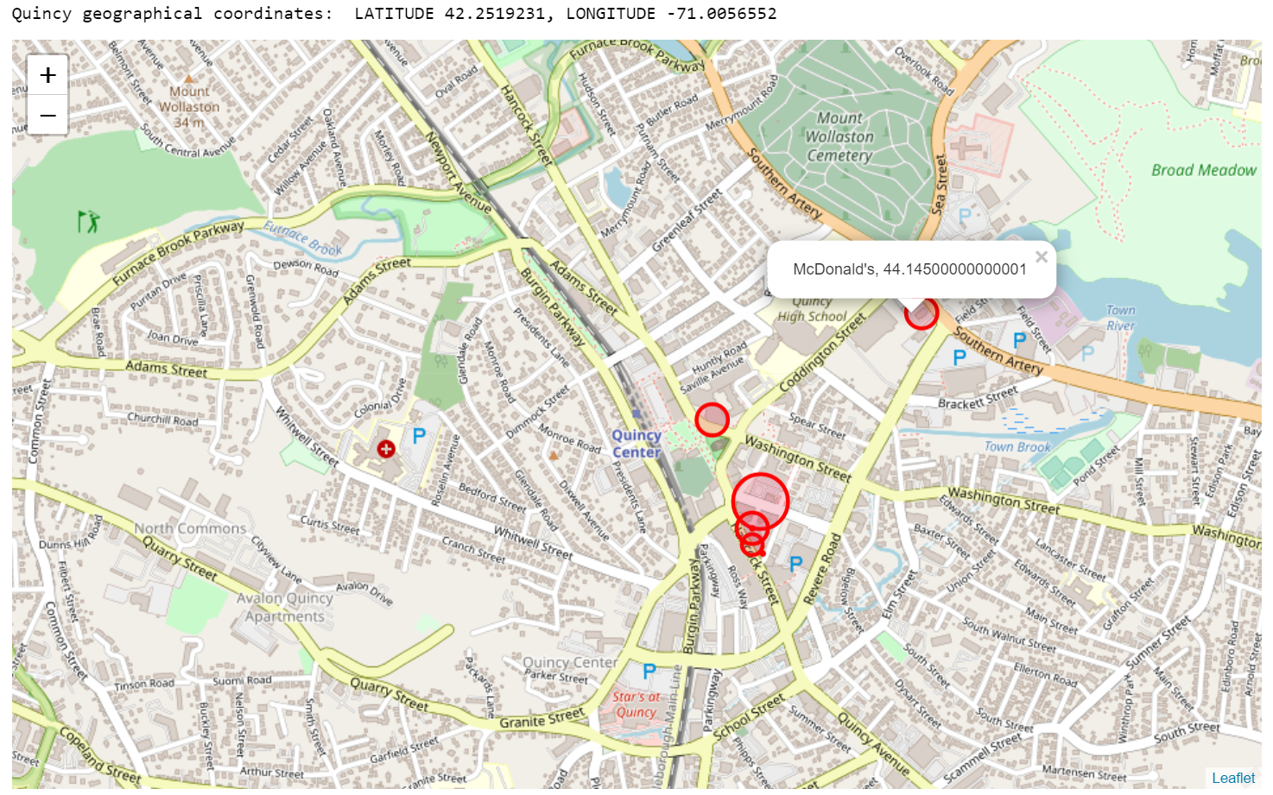

The map above was generated using location data obtained from Foursquare. Each point represents a restaurant .. the size of the circle indicates the total weight of each restaurant’s beef menu.

The map was generated from the dataframe below which shows various details for 10 restaurants located in Quincy, Massachusetts. Of the 10 restaurants, 4 have no beef menu options. Of the 6 that do, the total weight translates to the Greenhouse Gas Equivalent of making 14 round trips from Quincy to Boston (or 275 miles driven).

The source data was gathered directly from the menu websites and other datasets. The Beef Menu Mileage figure was calculated using the Scientific American’s emissions formula (1/2 lb beef = GHG equivalent of 9.81 miles driven).

The chart below is included to summarize the findings after analyzing each venue’s beef menu option with the highest weight (and how many a venue would need to sell to reach the equivalent of a car driven for 1 year).

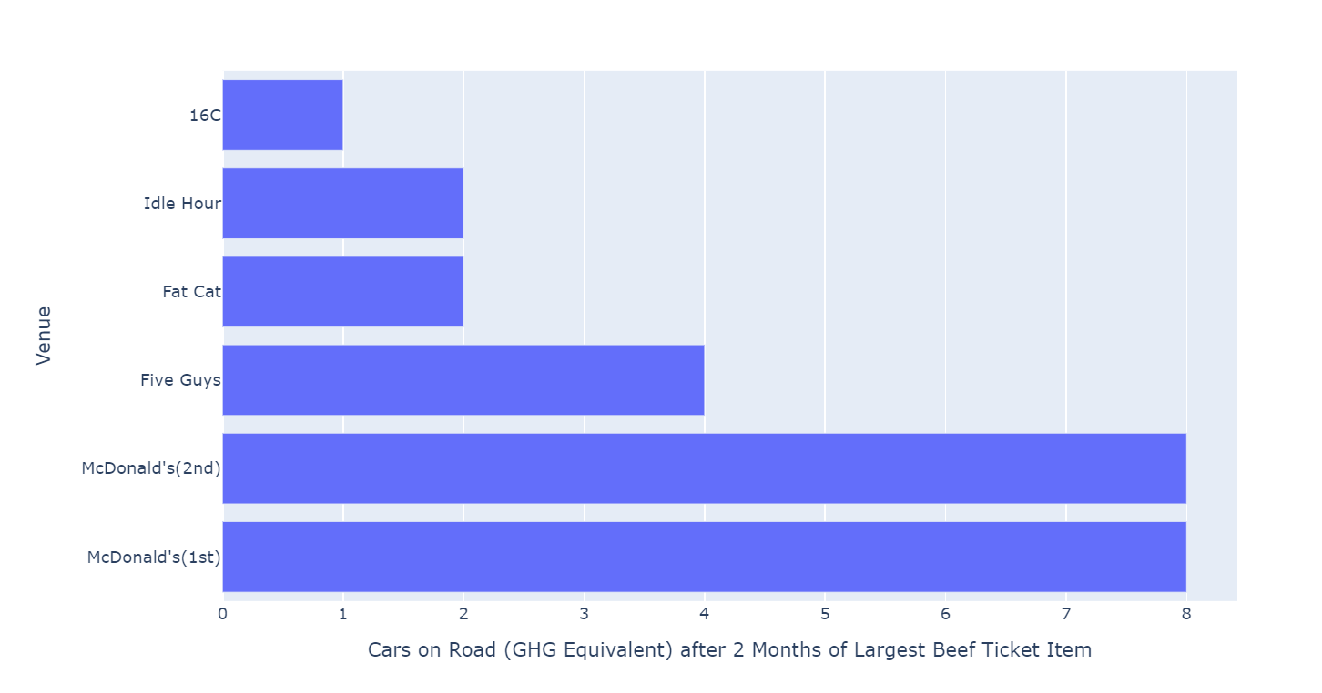

This data demonstrates the stunning impact of beef consumption at fast food restaurants and other retail venues on our climate. An alternative ending to this story exists with the partnering of Renewable Natural Gas production and the beef and dairy agriculture sector. Of note in this field is AgSTAR, an EPA/USDA-sponsored program that “promotes the use of biogas recovery systems to reduce methane emissions from livestock waste” ( LINK: [What EPA is Doing: AgSTAR | AgSTAR: Biogas Recovery in the Agriculture Sector | US EPA](https://www.epa.gov/agstar/what-epa-doing-agstar)). In the meantime, this data serves to assist in clarifying the current state of the industry, makes information available and accessible for delivery in public outreach, education, and legislative measures, and shines a light on areas of opportunity for corporate responsibility.

**INFORMATION SOURCES:**

McDonald’s menu dataset: <https://www.kaggle.com/mcdonalds/nutrition-facts>

Restaurant urls: <https://www.fatcatquincy.com/menu>, <https://www.16crestaurant.com/menu>, <https://idlehourquincy.com/menu/>, <http://www.fiveguys.com/Menu>, <https://shakingcrab.com/quincy>, <https://www.dunkindonuts.com/en/menu>.